**Bank loan Report Document**

**KPIs**

* **Total number of loan Applications**

SELECT COUNT(id) AS Total_loan_Applications

FROM financial_loan;



* **MTD Loan Applications**

SELECT COUNT(id) AS Total_loan _Applications

FROM financial_loan

WHERE MONTH(str_to_date(issue_date))= 12;



* **PMTD Loan Applications**

SELECT COUNT(id) AS PMTD_Total_loan_Applications

FROM financial_loan

WHERE MONTH(str_to_date(issue_date, ‘%d-%m-%Y)) = 11;



* **Total Funded Amount**

SELECT SUM(loan_amount) AS Total_funded_amount

FROM financial_loan;



* **MTD Funded Amount**

SELECT SUM(loan_amount) AS Total_funded_Amount

FROM financial_loan

WHERE MONTH(str_to_date(issue_date, ‘%d-%m-%Y’)) = 12



* **PMTD Funded Amount**

SELECT SUM(loan_amount) AS PMTD_Total_funded_Amount

FROM financial_loan

WHERE MONTH(str_to_date(issue_date, ‘%d-%m-%Y’)) = 11



* **Total Amount Received**

SELECT SUM(total_payment) AS Total_Amount_recieved

FROM financial_loan;



* **MTD Total Amount Received**

SELECT SUM(total_payment) AS Total_Amount_recieved

FROM financial_loan

WHERE MONTH(str_to_date(issue_date, '%d-%m-%Y')) = 12;



* **PMTD Total Amount Received**

SELECT SUM(total_payment) AS PMTD_Total_Amount_recieved

FROM financial_loan

WHERE MONTH(str_to_date(issue_date, '%d-%m-%Y')) = 11;



* **Average Interest Rate**

SELECT AVG(int_rate) AS Avg_Int_rate

FROM financial_loan;



* **MTD Avg Interest rate**

SELECT ROUND(AVG(int_rate), 4) * 100 AS MTD_Average_int_rate

FROM financial_loan

WHERE MONTH(str_to_date(issue_date, '%d-%m-%Y')) = 12;



* **PMTD Avg Interest rate**

SELECT ROUND(AVG(int_rate), 4) * 100 AS PMTD_Average_int_rate

FROM financial_loan

WHERE MONTH(str_to_date(issue_date, '%d-%m-%Y')) = 11;



* **Average Debt-to-Income Ratio (DTI)**

SELECT ROUND(AVG(dti), 4) * 100 AS Avg_dti

FROM financial_loan;



* **MTD Debt-to-Income Ratio**

SELECT ROUND(AVG(dti), 4) * 100 AS MTD_Avg_dti

FROM financial_loan

WHERE MONTH(str_to_date(issue_date, '%d-%m-%Y'));



* **PMTD Debt-to-Income ratio**

SELECT ROUND(AVG(dti), 4) * 100 AS MTD_Avg_dti

FROM financial_loan

WHERE MONTH(str_to_date(issue_date, '%d-%m-%Y')) = 12



**GOOD LOAN**

* **Good loan Application percentage**

SELECT

(COUNT(CASE WHEN loan_status = 'Fully Paid' OR loan_status = 'Current' THEN id END) * 100)

/

COUNT(id) AS Good_loan_percentage

FROM financial_loan;



* **Good loan Application**

SELECT COUNT(loan_status) As Good_loan_Application

FROM financial_loan

WHERE loan_status = 'Fully Paid'

OR loan_status = 'Current';



* **Good loan funded Amount**

SELECT SUM(loan_amount) AS loan_funded_amount

FROM financial_loan

WHERE loan_status = 'Fully Paid'

OR loan_status = 'Current' ;



* **Good loan total amount received**

SELECT SUM(total_payment) AS total_amount_received

FROM financial_loan

WHERE loan_status = 'Fully paid'

OR loan_status = 'Current';



**Bad Loans**

* **Bad loan Application %**

SELECT

(COUNT(CASE WHEN loan_status = 'Charged Off' THEN id END) * 100)

/

COUNT(id) AS Bad_loan_percentage

FROM financial_loan;



* **Bad Loan Applications**

SELECT COUNT(loan_status) AS Bad_loan_Application

FROM financial_loan

WHERE loan_status = 'Charged Off';



* **Bad loan funded Amount**

SELECT SUM(loan_amount) AS Bad_loan_amount

FROM financial_loan

WHERE loan_status = 'Charged Off';



* **Bad loan Total received Amount**

SELECT SUM(total_payment) AS Total_amount_received

FROM financial_loan;



**BANK LOAN STATUS**

SELECT

loan_status,

COUNT(id) AS Total_loan_Applications,

SUM(loan_amount) AS Total_funded_amount,

SUM(total_payment) AS Total_Amount_recieved,

ROUND(AVG(int_rate), 4) * 100 AS MTD_Average_int_rate,

ROUND(AVG(dti), 4) * 100 AS Avg_dti

FROM

financial_loan

GROUP BY

loan_status

ORDER BY

loan_status DESC;

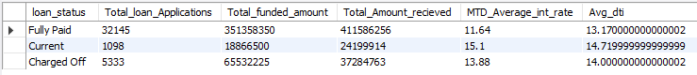

* **MTD**

SELECT

loan_status,

SUM(loan_amount) AS MTD_Funded_Amount,

SUM(total_payment) AS MTD_Amount_recieved

FROM

financial_loan

WHERE

MONTH(str_to_date(issue_date, '%d-%m-%Y')) = 12

GROUP BY

loan_status;

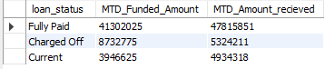

**CHARTS**

* **Monthly Trends by Issue Date**

SELECT

MONTH(STR_TO_DATE(issue_date, '%d-%m-%Y')) AS MonthNumber,

DATE_FORMAT(STR_TO_DATE(issue_date, '%d-%m-%Y'), '%M') AS MonthName,

COUNT(id) AS Total_loan_Applications,

SUM(loan_amount) AS Total_funded_amount,

SUM(total_payment) AS Total_Amount_received

FROM

financial_loan

GROUP BY

MonthNumber,

MonthName

ORDER BY

MonthNumber;

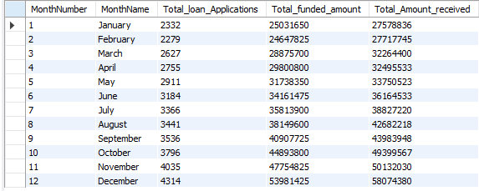

* **Regional Analysis by State**

SELECT

address_state,

SUM(loan_amount) AS Total_funded_amount,

COUNT(id) AS Total_loan_Applications,

SUM(total_payment) AS Total_Amount_received

FROM

financial_loan

GROUP BY

address_state

ORDER BY

address_state;

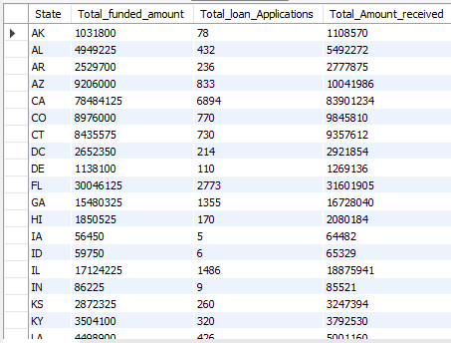

* **Loan Term Analysis**

SELECT

term AS loan_term,

SUM(loan_amount) AS Total_funded_amount,

COUNT(id) AS Total_loan_Applications,

SUM(total_payment) AS Total_Amount_received

FROM

financial_loan

GROUP BY

loan_term

ORDER BY

loan_term;



* **Employee Length Analysis**

SELECT

emp_length,

SUM(loan_amount) AS Total_funded_amount,

COUNT(id) AS Total_loan_Applications,

SUM(total_payment) AS Total_Amount_received

FROM financial_loan

GROUP BY

emp_length

ORDER BY

emp_length;

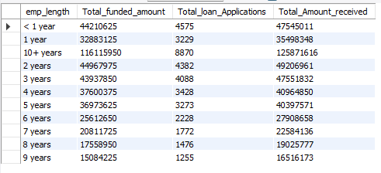

* **Loan Purpose Breakdown**

SELECT

purpose,

SUM(loan_amount) AS Total_funded_amount,

COUNT(id) AS Total_loan_Applications,

SUM(total_payment) AS Total_Amount_received

FROM

financial_loan

GROUP BY

purpose;

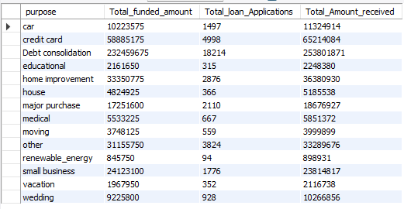

* **Home Ownership Analysis**

SELECT

home_ownership,

SUM(loan_amount) AS Total_funded_amount,

COUNT(id) AS Total_loan_Applications,

SUM(total_payment) AS Total_Amount_received

FROM

financial_loan

GROUP BY

home_ownership

ORDER BY

home_ownership;

